 CHEMICAL ENGINEERING TRANSACTIONS  VOL. xxx, 2026 | A publication of  
The Italian Association
of Chemical Engineering
Online at www.cetjournal.it

Guest Editors: Marco Bravi, Antonio Marzocchella, Giuseppe Caputo
Copyright © 2026, AIDIC Servizi S.r.l.
ISBN 979-12-81206-xx-x; ISSN 2283-9216

Bromelain-Assisted Hydrolysis of Swordfish (Xiphias gladius) Skin: Process Optimization and Hydrolysate Characterization
Angela Sorrentino^{a,}*, Mariacristina D’Ascoli^{b}, Aniello Falcianoª, Prospero Di Pierro^{a,b}
ªCentre for Innovation and Development in Food Industry, University of Naples Federico II, Via Università 133, 80055, Portici (NA), Italy
^{b}Department of Agricultural Sciences, University of Naples Federico II, Piazza Carlo di Bordone, 80055, Portici (NA), Italy.
angela.sorrentino@unina.it
Substantial quantities of by-products are generated in the fish processing industry such as skin, bones, heads, and viscera, which are often underutilized and mainly destined for fishmeal or fertilizer production. Enzymatic hydrolysis represents a sustainable strategy to valorize these wastes by producing fish protein hydrolysates (FPHs), which are rich in bioactive peptides and amino acids. This process occurs under mild conditions and depends on enzyme-specific pH and temperature, making it suitable for food applications. Bromelain, a proteolytic enzyme extracted from pineapple, is widely used in the food industry due to its ability to efficiently break peptide bonds in proteins.
The present study focused on optimizing the enzymatic hydrolysis of swordfish (Xiphias gladius) skin using bromelain to obtain FPHs with altered physicochemical and technological properties. Optimal hydrolysis conditions were identified as pH 5, a solid-to-liquid ratio of 1:1, and an incubation time of 15 minutes. Following optimization, the effects of different bromelain concentrations on functional properties such as emulsifying capacity, solubility, and fat-retaining capacity were evaluated. Overall, this approach supports waste valorization, sustainability, and the development of a circular bioeconomy in the fish processing sector.
  - Introduction
Due to global population growth and the resulting rapid increase in urbanization and industrialization, fisheries and aquaculture production have seen a massive increase, driven primarily by the development of fishing technologies. As a result, there has been a significant increase in the amount of fish waste worldwide: it has been estimated that approximately two-thirds of the total amount of fish is discarded as waste, creating enormous economic and environmental concerns (Coppola et al., 2021). In fact, over 70% of all fish caught undergoes further processing before being released to the market (Hou et al., 2016), resulting in the production of large quantities (approximately 20–80%) of fish waste, depending on the level of processing (e.g., gutting, scaling, filleting) and species, because each species has a specific composition, size, shape, and intrinsic chemistry (Arnaud et al., 2018). These operations generate waste that primarily includes muscle trimmings (15–20%), skin and fins (1–3%), bones (9–15%), heads (9–12%), viscera (12–18%), and scales (5%) (Coppola et al., 2021). For this reason, the disposal and recovery of this waste have become a key issue to address. With the growing focus on the circular economy, the exploitation of underutilized or discarded marine material can represent a sustainable strategy for the implementation of a circular bioeconomy, with the production of high-value-added materials (Coppola et al., 2021). Currently, fish waste is mainly used in the fishmeal industry, as it contains almost the same amount of protein as muscle. Furthermore, the nutritional composition of fish waste allows it to be used as a nutrient for plants or as a compost enrichment. Indeed, fish waste can be processed to produce various fertilizers. Fish by-products are a nutritionally important source of protein, fatty acids, and minerals, as their composition is similar to that of fish fillets and other food products used for consumption (Coppola et al., 2021).
To maximize natural resources, the European Commission has approved a long-term plan called "Blue Growth," which envisions paying particular attention to fisheries resources to protect the environment from industrial pollution. The enormous amount of protein that could be extracted from fish by-products (approximately 30–40% of the total weight) is one of the most interesting aspects. Every year, more than 20 million tons of protein are produced from fish tissues, such as fins, heads, skin, and viscera, which are discarded as waste (Rajabimashhadi et al., 2023). This waste is composed of over 75% collagen, which can be extracted and used in both the pharmaceutical and food industries (Usman et al., 2022). Due to their high protein content, lack of risk of disease transmission, and high bioactivity, the use of fish by-products as a new source of collagen has attracted growing attention. The marine collagen market is estimated to reach USD 983.84 million by 2025, growing at a compound annual growth rate (CAGR) of 7.4% (Jafari et al., 2020).
The conversion of inexpensive fish processing byproducts into valuable products has recently been of great interest to food scientists worldwide. Currently, fish protein hydrolysates are considered the most important source of bioactive proteins and peptides. Protein hydrolysates are produced by the enzymatic degradation of proteins into smaller peptides. Generally, they are small peptide fragments containing between 2 and 20 amino acids. Protein hydrolysis decreases the size of the peptide and thus makes the amino acids more available for various physiological functions in the human body. The proper utilization of fish processing waste and underutilized fish species could be achieved by converting these materials into fish protein hydrolysates (Coppola et al., 2021). Enzymatic hydrolysis is typically performed over a period of one to several hours under mild conditions: slightly elevated temperatures (typically around 35–65°C) and a specific pH, depending on the optimal requirements of the enzymes used: alcalase, papain, bromelain, neutrase, or pepsin. Proteins obtained through enzymatic hydrolysis can be widely used as emulsifiers, antioxidants, and fat substitutes in meat products (Usman et al., 2022).
Bromelain, a proteolytic enzyme derived from pineapple, plays a significant role in the production of fish protein hydrolysates. Bromelain catalyzes peptide bond breaking into proteins and is used in various food sectors. The present study aimed to optimize the swordfish (Xiphias gladius) skin hydrolysis conditions to produce protein hydrolysates (SfPH) with modified physicochemical properties using bromelain. To this aim, several key parameters for process optimization were investigated (pH, solid-liquid ratio, enzyme concentration and incubation time). The technological properties of the hydrolysates were subsequently evaluated, such as solubility, fat-retaining, emulsifying and foaming capacity.
  - Materials and Methods
    - Materials
Swordfish (Xiphias gladius) skin was obtained from fishmongers in the municipality of Portici (Naples, Italy). Bromelain (EC 3.4.22.32 from the pineapple stem) was purchased in the form of an enzyme preparation called "Bromelain for food" from Creative Enzymes (Shirley, NY, USA). Deionized water from a water purification system was used to prepare all solutions; all other reagents and solvents used were of analytical grade.
    - Swordfish skin homogenate preparation and characterization
The swordfish skin was carefully cleaned to remove any meat residue and cut into pieces of approximately 1 cm², immersed in distilled water (1:0.5 ratio w/v), and autoclaved at 121°C for 15 min to deactivate any endogenous enzymes, reduce the microbial load normally present, and facilitate subsequent homogenization. The skin was then broken down and homogenized in a blade blender (Kenwood Triblade XL HBM60) for 1 min, and the resulting homogenate (SfSH) was aliquoted and stored at -20 °C until further analysis. The moisture content in the raw homogenate was determined by drying to constant mass. The contents of ash, fat, were analyzed following the AOAC procedures. Total nitrogen and protein content were determined by the Kjeldahl method.
    - Bromelain treatments and degree of hydrolysis
The Swordfish skin homogenate (SfSH) was subjected to bromelain hydrolysis in different conditions. Briefly, in preliminar experiments, 6 g of SfSH were incubated at 60 °C/ 150 rpm in orbital shaker (Forma Scientific, USA) for 18 h, with a fixed amount of bromelain (1.5 U/g DW) in different buffers (0.1 M acetate buffer pH 4 and 5; 0.1 phosphate buffer pH 6, 7 and 8) and a final solid:liquid (S:L) ratio of 1:1. Subsequently, the pH was fixed to 5 and the S:L ratio was varied between 0.5 and 4. Finally, different amounts of enzyme (0.02, 0.03, 0.08, 0.17, 0.5 and 0.75 U/g DW) were tested at pH 5 and 1:1 S:L ratio. In all the assays the temperature was maintained at 60°C and the time was maintained for 18 h in the preliminary screening then shortened at 15 min in the optimized condition assays.
After incubation, the samples were heat-treated at 100°C for 30 min in a water bath to deactivate the enzyme and then centrifuged at 16,000 × g for 7 min. One aliquot of the supernatants was immediately used for the determination of free primary amine using the OPA Assay (Lee and Drescher, 1978), and the remaining part was freeze-dried (Lyovapor L-300 freeze-dryer, Büchi, Switzerland) and used for further analyses. The moles of free primary amines in the hydrolysed samples were obtained by extrapolation from the equation of a calibration line obtained with concentrations between 0.075 and 1.2 mM of leucine (y = 7354 x – 0.06; R² = 0.999). The degree of hydrolysis (DH %) was calculated as the percentage of mol of free primary amines compared to the mol of total Kjeldahl nitrogen.
    - SDS-PAGE
The molecular masses of the swordfish protein hydrolysed (SfPH) samples were evaluated electrophoretically by SDS-PAGE 15 %. The supernatants were diluted 1:10 with deionized water and sample buffer (Laemli, 1970). The samples were then boiled in a water bath at 100 °C for 5 min. Electrophoresis was performed at a constant voltage of 120 V; the gels were stained for 1 h with Coomassie Brilliant Blue solution (1 % dissolved in 50 % methanol and 10 % acetic acid) and then destained for 18 h ours in 10 % acetic acid, 10 % methanol solution.
    - Solubility, oil-holding capacity, emulsifying and foaming properties
The water solubility index (WSI %) of freeze-dried SfPHs was determined according to the following method. Each lyophilized SfPH (50 mg) was dissolved in 1.5 mL of distilled water. The mixtures were then incubated in an orbital shaker (Forma Scientific) at 30 °C with shaking at 180 rpm for 1 h and then centrifuged for 10 min at 15,000 × g. The pellets were then dried for 24 h in an oven at 105 ± 2 °C. The Water Solubility Index (WSI) was determined using the equation 1.
$$WSI (\%)=\frac{Weight of soluble solids}{Initial dry weight}×100$$ | (1)
The oil holding capacity (OHC) was determined following the AACC 56-30.01 method: each lyophilized SfPH (0.3 g) was suspended in 3 g of sunflower oil and vortexed for 10 s, every 5 minutes, for 30 min. The suspension was then centrifuged at 1000 ×g for 10 minutes and the supernatant was gently poured and discarded, even the oil on the wall of the centrifuge tube was carefully sucked up with oil absorption papers. The mass of the precipitate was used to calculate the OHC using the formula in the equation 2.
$$OHC =\frac{Weight of oil soaked sample}{Initial dry weight}$$ | (2)
For the emulsifying properties, 0.3 g of freeze-dried SfPHs were solubilized in 30 mL of distilled water and then mixed with 10 mL of sunflower seed oil was. The mixtures were homogenized for 1 minute at 20,000 rpm using a high-speed homogenizer (OV5 Homogenizer, Velp scientifica Srl, Usmate IT), and afterwards 50 µL were taken from the bottom of the beaker and diluted with 10 mL of a 0.1% (w/v) SDS solution. Then, the turbidity of each solution was evaluated at 500 nm using a UV/VIS spectrophotometer (V-730, Jasco, South Africa). Two spectrophotometric readings were taken for each sample: one at time 0 and one after 10 minutes. The emulsion-forming ability (EAI) and the emulsion stability (ESI) were calculated using the respective formulas of equations 3 and 4.
$EAI \left(\frac{m^{2}}{g}\right)=\frac{2 × 2.303 × A × DF}{l × C × ð}$ ; $ESI (\%)=100-\frac{{EAI}_{0}-{EAI}_{10}}{{EAI}_{10}}×100$ | (3) (4)
Where “A” is the Absorbance at 500 nm, DF is the dilution factor, “l” is the optical path of the cuvette (m); “C” is the concentration of proteins in aqueous phase (g/m³), “ð” is the volumetric fraction of sunflower oil (0.25).
The foaming capacity (FC) and foam stability (FS) were determined by dissolving 0.2 g of freeze-dried SfPHs in 20 mL of distilled water at room temperature in a 50 mL volumetric cylinder; the sample was homogenized (2 min, 16,000 rpm) with a high-speed homogenizer (OV5 homogenizer, Velp scientifica Srl, Usmate, IT). The FC and FS were calculated by evaluating the volume of foam obtained after 2 minutes of homogenization and measuring the foam loss over a 5-minute period, according to the equations 5 and 6.
$FC \left(\%\right)=\frac{V_{2}-V_{1}}{V_{1}}×100$ ; $FS (\%)=\frac{Foam volume after each min }{Initial foam volume}×100$ | (5) (6)
being V₁ and V₂ the pre- and post-homogenization volumes, respectively (Ramondo et al., 2024).
  - Results and Discussion
    - Proximal Composition
The proximal composition of the swordfish skin homogenate, calculated on a dry basis, is reported in Table 1. The homogenate contained 59 % of fat, while the protein content was 37.5 %. Ash was the component with the least amount within the swordfish skin homogenate (3.5 % on a dry basis). The obtained results are in line with other data reported in literature regarding the proximal composition of swordfish skin (Blanco et al., 2017).
Table 1: Proximal composition of swordfish (Xiphias gladius) skin homogenate on dry weight basis (%).
Moisture | Proteins | Lipids |  | Ashes
----- | 37.50 ± 0.37 | 59.00 ± 0.39 |  | 3.50 ± 0.21
    - Optimization of enzymatic hydrolysis conditions
The degree of hydrolysis (DH) represents the percentage of peptide bonds cleaved during enzymatic treatment and is a key indicator of enzyme efficiency and process performance (Rutherfurd, 2010). In this study, bromelain-assisted hydrolysis of swordfish skin homogenate (SfSH) was optimized by investigating the effects of pH, solid:liquid (S:L) ratio, incubation time, and enzyme:substrate (E:S) ratio on DH (Figure 1).
The effect of pH on hydrolysis efficiency is reported in Figure 1a. At pH 4, DH reached 9.6%, while the highest DH value (13.1%) was observed at pH 5, indicating optimal bromelain activity under mildly acidic conditions. Beyond this pH, DH progressively decreased, reaching 11.25%, 9.25%, and 8.88% at pH 6, 7, and 8, respectively. These results are consistent with previous studies reporting maximum bromelain activity at pH 5 (Saptarini et al., 2019). Consequently, pH 5 was selected for subsequent experiments.
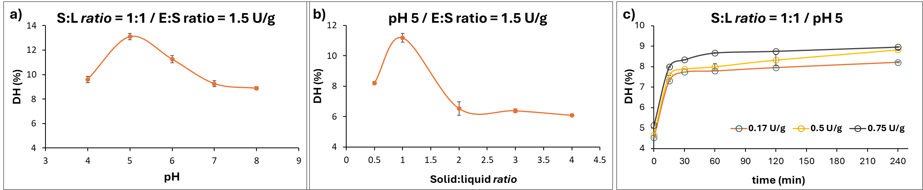
Figure 1: Degree of Hydrolysis (DH %) of SfSH at different pH (a), solid:liquid ratio (b), incubation time, and enzyme:substrate ratios (c). The assay was conducted at 60 °C for 18 h (a and b) and 4 h (c).
The influence of the S:L ratio on DH was evaluated in the range of 1:0.5 to 1:4 at pH 5, 60 °C, and 18 h of incubation using 1.5 U/g bromelain (Figure 1b). The optimal ratio was 1:1, yielding the highest DH (11.17%). Lower liquid content (1:0.5) resulted in reduced DH (8.20%), likely due to poor substrate enzyme contact caused by sample adhesion to the tube walls. Conversely, increasing dilution led to a marked decrease in DH (6.53–6.08%), probably as a result of enzyme dilution, in agreement with literature data (Noman et al., 2018).
The combined effects of incubation time and E:S ratio on DH are shown in Figure 1c. Three E:S ratios (0.17, 0.5, and 0.75 U/g) were tested over 240 min at pH 5 and an S:L ratio of 1:1. Regardless of enzyme concentration, DH increased rapidly within the first 15 min, rising from an initial value of approximately 4.8% to 7.31%, 7.57%, and 7.99%, respectively. After this initial phase, DH reached a plateau, indicating substrate limitation due to the progressive depletion of cleavable peptide bonds (Salwanee et al., 2013). Based on these results, the optimized conditions for SfPH production were set to 1:1 S/L ratio, pH 5, and 15 min incubation time. an incubation time.
    - Electrophoretic analysis
SfPH samples produced under optimized conditions (15 min, 60 °C, S:L 1:1) with increasing E:S ratios were analyzed by SDS-PAGE (Figure 2). The control sample, incubated without enzyme, showed a continuous smear of high-molecular-weight proteins extending from the well down to approximately 30 kDa, with intense bands between 250 and 100 kDa. These proteins are likely attributable to collagen chains, which typically exhibit molecular weights around 300 kDa.
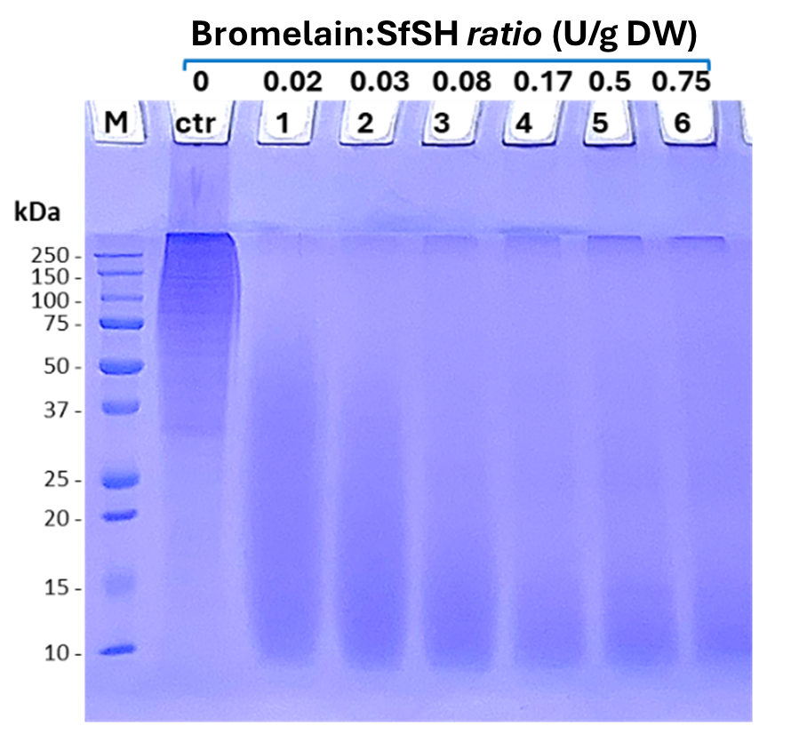
Figure 2: Protein profile in 15% SDS-PAGE of SfPH obtained with increasing amounts of bromelain. Ctr, control incubated without enzyme. M, molecular weight marker (Precision Plus Protein All Blue Standard, Biorad).
Enzymatic treatment with bromelain markedly altered the protein profile. At the lowest enzyme concentration (0.05% bromelain), high-molecular-weight proteins were efficiently hydrolyzed into fragments ranging from 50 to 10 kDa. Increasing the enzyme concentration led to the progressive formation of lower-molecular-weight peptides, particularly in the 10–15 kDa range, as previously reported for fish protein hydrolysates (He et al., 2013). At higher E:S ratios, deposition signals appeared in the wells and stacking gel, suggesting the presence of insoluble protein aggregates that become partially solubilized upon extensive proteolysis. Under these conditions, low-molecular-weight peptides predominated. Since peptides are known to exhibit limited techno-functional properties, excessive hydrolysis of proteins is not recommended when it is desirable to preserve the foaming and emulsifying properties. Thus, only hydrolysates obtained with lower bromelain concentrations (0.02, 0.03, 0.08 U/g) were selected for subsequent functional characterization.
    - Techno-functional properties
The water solubility index (WSI) of SfPHs increased progressively with increasing E:S ratio (Figure 3a). The control sample exhibited a WSI of 56.30%, whereas hydrolysed samples reached values up to 71.10% at the highest bromelain concentration (Elgaoud et al., 2023). Enhanced solubility is associated with protein size reduction and the release of small, highly soluble peptides, as well as with the exposure of hydrophilic groups that improve protein–water interactions (Eberhardt et al., 2019). Oil-holding capacity (OHC) showed the opposite trend (Figure 3b). The control sample, rich in high-molecular-weight proteins, displayed the highest OHC due to its ability to form a protein network capable of entrapping lipids. Increasing bromelain concentration significantly reduced OHC, indicating that excessive hydrolysis compromises the structural integrity required for fat retention. Similar behavior has been reported for other fish protein hydrolysates (He et al., 2013).
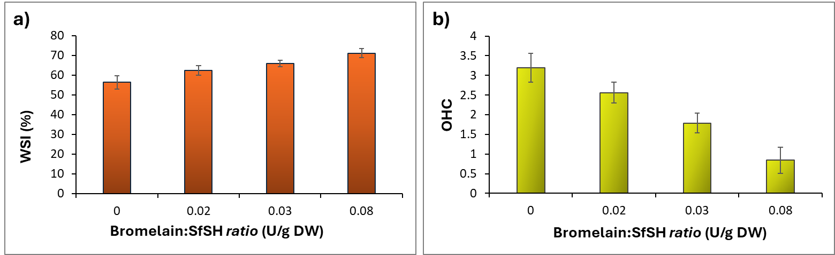
Figure 3: WSI and OHC of SfPH obtained with increasing bromelain: SfSH ratio.
The emulsifying properties of SfPHs are reported in Figure 4a. The sample treated with the lowest bromelain concentration (0.02 U/g) exhibited the highest emulsifying activity index (EAI, 34.29 m² g⁻¹), outperforming both the control and samples produced with higher enzyme levels. Increased hydrolysis resulted in lower EAI values, likely due to the predominance of small peptides with limited interfacial activity (Cho et al., 2008). Although the 0.02 U/g sample showed the best emulsifying activity, its emulsion stability index (ESI) was lower than that of the control, reflecting the reduced ability of low-molecular-weight peptides to stabilize oil–water interfaces over time (Souissi et al., 2007).
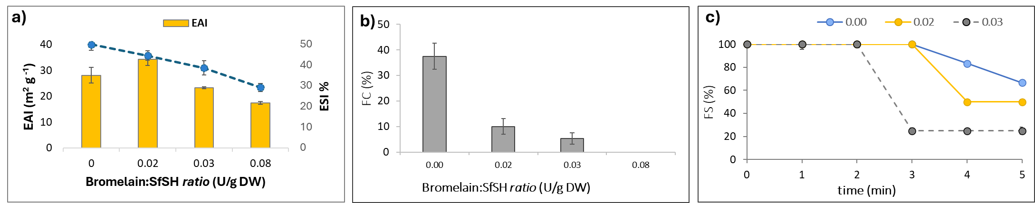
Figure 4: Emulsifying Activity Index (EAI) and Emulsion Stability Index (ESI) (a), Foaming Capacity (FC, b) and Foaming Stability (FS, c) of SfPHs with increasing bromelain:SfSH ratio.
Foaming capacity (FC) and foam stability (FS) decreased markedly with increasing bromelain concentration (Figure 4b, c). The control sample exhibited the highest FC (37.50%) and greater foam stability, while hydrolyzed samples showed progressively reduced foaming performance. At the highest enzyme level tested, the ability to form foam was completely lost. These results confirm that high-molecular-weight proteins are essential for foam formation and stabilization, whereas extensive hydrolysis generates peptides that are ineffective in maintaining air–water interfaces (Van der Ven et al., 2002).
  - Conclusions
Protein hydrolysates (SfPHs) were obtained by bromelain treatment on swordfish skin. Several key parameters for process optimization were identified, including the optimal enzyme pH (pH 5), the most effective solid-liquid ratio for the enzyme (1:1), and the most convenient incubation time (15 min). The results obtained about technological properties demonstrate that enzymatic hydrolysis impaired the ability to retain fat, form foam and emulsions, as well as their stability. However, only the sample treated with 0.02 U/g of bromelain showed an improvement in emulsifying capacity compared to the control, but its ability to stabilize the emulsion was still lower than that of the non-enzymatically treated samples. However, enzymatic hydrolysis improved the solubility of all treated samples suggesting a potential application as a source of peptides to enrich foods and beverages.
References
Arnaud C., de Lamballerie M., and Pottier L., 2018, Effect of high-pressure processing on the preservation of frozen and rethawed sliced cod (Gadus morhua) and salmon (Salmo salar) fillets. High Pressure Research, 38(1), 62-79.
Blanco M., Vázquez J.A., Pérez-Martín R.I., and Sotelo C.G. (2017). Hydrolysates of fish skin collagen: An opportunity for valorizing fish industry byproducts. Marine drugs, 15(5), 131.
Cho S.S., Lee H.K., Han C.W., Seong E.S., Yu C.Y., Kim M.J., and Lim J.D., 2008, Physicochemical properties of isolated peptides from Hwangtae (yellowish dried pollack) protein hydrolysate. Preventive Nutrition and Food Science, 13(3), 204-211.
Coppola D., Lauritano C., Palma Esposito F., Riccio G., Rizzo C., and de Pascale D, 2021, Fish waste: From problem to valuable resource. Marine drugs, 19(2), 116.
Eberhardt A., López E.C., Ceruti R.J., Marino F., Mammarella E.J., Manzo R.M., and Sihufe G.A., 2019, Influence of the degree of hydrolysis on the bioactive properties of whey protein hydrolysates using Alcalase®. International Journal of Dairy Technology, 72(4), 573-584.
Elgaoud I., Hamed F., Lassoued I., Chamkha M., Oulahal N., Degraeve P., and Barkia A., 2023, Production of Hydrolysates from Swordfish (Xiphias gladius) Head Muscle as New Protein Source: Evaluation of Nutritional, Antioxidant and Functional Properties. Waste and Biomass Valorization, 1-16.
He S., Franco C., and Zhang W., 2013, Functions, applications and production of protein hydrolysates from fish processing co-products (FPCP). Food Research International, 50(1), 289-297.
Jafari H., Lista A., Siekapen M.M., Ghaffari-Bohlouli P., Nie L., Alimoradi H., and Shavandi A., 2020, Fish collagen: Extraction, characterization, and applications for biomaterials engineering. Polymers, 12, 2230.
Laemli U.K. 1970. Cleavage of structural proteins during the assembly of the head of bacteriophage T4. Nature 277:680-685.
Lee K., Drescher D.G. 1978, Fluorometric amino-acid analysis with o-phthaldialdehyde (OPA), International Journal of Biochemistry, 9, 457–467.
Noman A., Xu Y., Al-Bukhaiti W.Q., Abed S.M., Ali A.H., Ramadhan A.H., and Xia W., 2018, Influence of enzymatic hydrolysis conditions on the degree of hydrolysis and functional properties of protein hydrolysate obtained from Chinese sturgeon (Acipenser sinensis) by using papain enzyme. Process Biochemistry, 67, 19-28.
Rajabimashhadi Z., Gallo N., Salvatore L., and Lionetto F., 2023, Collagen derived from fish industry waste: progresses and challenges. Polymers, 15(3), 544.
Ramondo A., Marulo S., Sorrentino A., Masi P., Di Pierro P., 2024, Modification of physicochemical and functional properties of Pumpkin seeds Protein Isolate (PsPI) by high-intensity ultrasound: Effect of treatment time, ACS Food Science and Technology, 4:40-48.
Salwanee S., Wan Aida W.M., Mamot S., Maskat M.Y. and Ibrahim S, 2013. Effects of enzyme concentration, temperature, pH and time on the degree of hydrolysis of protein extract from viscera of tuna (Euthynnus affinis) by using alcalase, Sains Malaysiana, 42(3), 279-287.
Saptarini N.M., Rahayu D., and Kusuma, S.A. F., 2019. Protease activity and characterization of bromelain extract of pineapple (Ananas comusus) crown from Subang, Indonesia. Rasayan Journal of Chemistry, 12(4), 2074-2081.
Souissi N., Bougatef A., Triki-Ellouz Y., and Nasri M., 2007, Biochemical and functional properties of sardinella (Sardinella aurita) by-product hydrolysates. Food technology and biotechnology, 45(2), 187-194.
Usman M., Sahar A., Inam‐Ur‐Raheem M., Rahman U.U., Sameen A., and Aadil R.M., 2022, Gelatin extraction from fish waste and potential applications in food sector, International Journal of Food Science and Technololy, 57(1), 154-163.
Van der Ven C., Gruppen H., de Bont D.B., and Voragen A.G., 2002, Correlations between biochemical characteristics and foam-forming and-stabilizing ability of whey and casein hydrolysates. Journal of Agriculture and Food Chemistry, 50(10), 2938-2946.

